Market Basket Analysis
Kartik Saini, Khushi Sharma, Akshaj Agarwal
Mentor: Ms. Anjali Sardana
Computer Science Engineering-Artificial Intelligence Machine learning Department ABES Engineering College
Khushi.20B1531039@abes.ac.in
Akshaj.20b1531044@abes.ac.in
Kartik.20B1531055@abes.ac.in

Abstract— Data analysis plays a vital role in the present era as it helps us to understand patterns by exploring them in meaningful ways. Market basket is one of the main methods used to find frequently occurring items in a transactional database. As these databases are large, it is impossible to read the database manually and extract the pattern. Market Basket Analysis is one of the main techniques of data mining that focuses on finding the purchase patterns of the customers.
Market Basket Analysis will be implemented by using the Apriori algorithm. This algorithm determines the frequent data or item set from the transaction database.

The problem many retailers face is the placement of the items. They are unaware of the purchasing habits of the customer.
Market basket analysis can help the shop managers determine the strong relationships between the items which ultimately helps them to put products that co-occur together close to one another.

Keywords— Transactions, Database, Apriori, Market Basket, Data Analysis
- Introduction
Market basket analysis is that technology that is used to analyze the items/goods in one or more shopping baskets that a customer has in one particular moment.
Market basket analysis application ought to be designed and implemented at a supermarket not only owing to being able to help the sales promotion design but also able to be made as a reference to re-manage item stock’ incoming and outcoming in the warehouse.

Market basket analysis is a data mining technique used by retailers to increase sales by better understanding customer purchasing patterns. It involves analyzing large data sets, such as purchase history, to reveal product groupings, as well as products that are likely to be purchased together.

Implementation of market basket analysis requires a background in statistics and data science, as well as some algorithmic computer programming skills.

There are two types of market basket analysis:

- Predictive market basket analysis: This type considers items purchased in sequence to determine cross-sell.

- Differential market basket analysis: This type considers data across different stores, as well as purchases from different customer groups during different times of the day, month or year. If a rule holds in one dimension (like store, time period or customer group), but does not hold in the others, analysts can determine the factors responsible for the exception. These insights can lead to new product offers that drive higher sales.

In market basket analysis, association rules are used to predict the likelihood of products being purchased together. Association rules count the frequency of items that occur together, seeking to find associations that occur far more often than expected.

Algorithms that use association rules include AIS, SETM and Apriori. The Apriori algorithm is commonly cited by data scientists in research articles about market basket analysis and is used to identify frequent items in the database, then evaluate their frequency as the datasets are expanded to larger sizes.

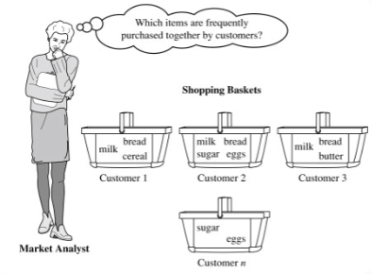

Fig i: Customer purchase pattern
- PROBLEM STATEMENT

The problem many retailers face is the placement of the items. They are unaware of the purchasing habits of the customer.

Market basket analysis can help the shop managers determine the strong relationships between the items which ultimately helps them to put products that co-occur together close to one another.

- LITERATURE REVIEW
The related work associated with our project is given below by the different research papers read whose summary is as follows:
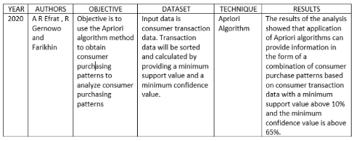
Research Paper 1:
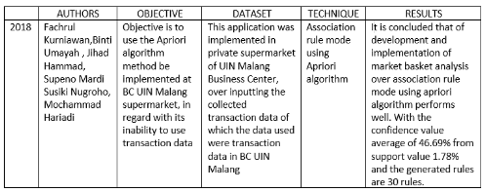
Research Paper 2:

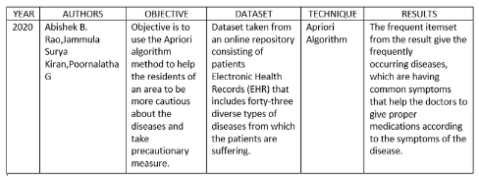
Research Paper 3:
- PROJECT OBJECTIVE
To analyze the Brazilian E-Commerce Public Dataset by Olist, taken from Kaggle. The dataset has information of 100k orders from 2016 to 2018 made at multiple marketplaces in Brazil.
Its features allows viewing an order from multiple dimensions: from order status, price, payment, product attributes.

To implement an algorithm best suited for the market basket analysis which would be apriori algorithm. Market Basket Analysis will be implemented by using the Apriori algorithm. This algorithm determines the frequent data or item set from the transaction database.

To perform market basket analysis using apriori algorithm and find out the strong relationships between the items which ultimately helps shopkeepers to put products that co-occur together close to one another.

- PROPOSED METHODOLOGY
The proposed methodology related to our project is given below:

Step 1: Choosing the appropriate dataset. Here we will use Brazilian E-Commerce Public Dataset by Olist
Step 2: Determine what constitutes an item, an itemset, and a transaction. This will depend on the dataset we're using and the question we're attempting to answer.

Step 3: We will translate the item category names, Convert product IDs to product category names,
Construct transactions from order and product data and Summarize final transaction data.

Step 4:We now perform Association Rules and Metrics, One-hot encode the transaction data, Compute the support metric, Compute the item count distribution over transactions, Create a column for an itemset with multiple items, Aggregate the dataset further by combining product sub-categories
Compute the confidence metric.

Step 5:Performing the Apriori Algorithm and Pruning, Computing association rules from Apriori output in the form of table given below, The leverage metric, Visualizing patterns in metrics.

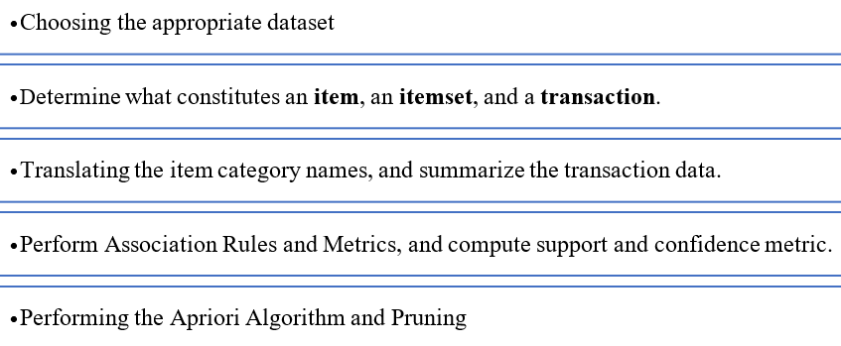

- DESIGN AND IMPLEMENTATION
The design and implementation of our project is as follows:
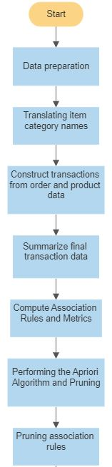

Fig.3. Work Flow Diagram

We will first choose the appropriate dataset. Here we will use Brazilian E-Commerce Public Dataset by Olist.
We then determine what constitutes an item, an itemset, and a transaction. This will depend on the dataset we're using and the question we're attempting to answer.
We will translate the item category names, Convert product IDs to product category names,
Construct transactions from order and product data and Summarize final transaction data.
We now perform Association Rules and Metrics, One-hot encode the transaction data, Compute the support metric, Compute the item count distribution over transactions, Create a column for an itemset with multiple items, Aggregate the dataset further by combining product sub-categories
Compute the confidence metric.
Performing the Apriori Algorithm and Pruning, Computing association rules from Apriori output in the form of table given below, The leverage metric, Visualizing patterns in metrics.

- RESULTS AND DISCUSSION
The result we got from analyzing the transaction is given below in Fig.3.
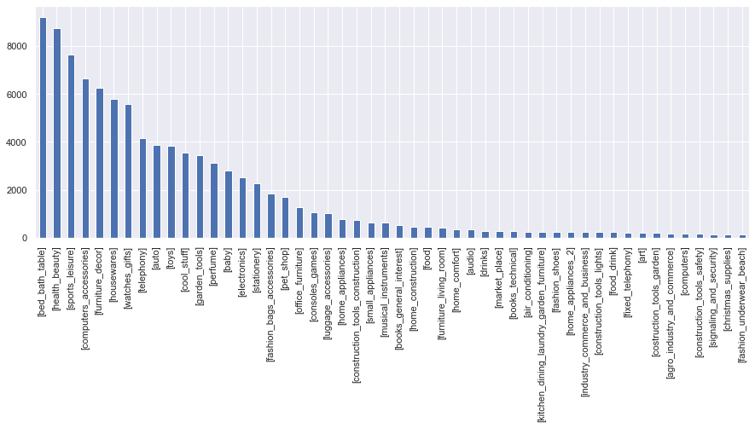

Fig.4. Plot of 50 largest categories of transactions

Fig.3. shows that the maximum category used in the transaction is [bed_bath_table} with more than 8000+ transactions followed by [health_beauty] , [sports_leisure] , etc.
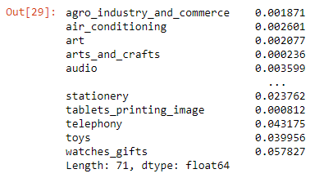

Fig.5. Computed the support metric

References
The heading of the References section must not be numbered. All reference items must be in 8 pt font. Please use Regular and Italic styles to distinguish different fields as shown in the References section. Number the reference items consecutively in square brackets (e.g. [1]).
When referring to a reference item, please simply use the reference number, as in [2]. Do not use “Ref. [3]” or “Reference [3]” except at the beginning of a sentence, e.g. “Reference [3] shows …”. Multiple references are each numbered with separate brackets (e.g. [2], [3], [4]–[6]).
Examples of reference items of different categories shown in the References section include:
- example of a book in [1]
- example of a book in a series in [2]
- example of a journal article in [3]
- example of a conference paper in [4]
- example of a patent in [5]
- example of a website in [6]
- example of a web page in [7]
- example of a databook as a manual in [8]
- example of a datasheet in [9]
- example of a master’s thesis in [10]
- example of a technical report in [11]
- example of a standard in [12]
- Conclusions
Causal Productions has used its best efforts to ensure that the templates have the same appearance.
Acknowledgment
The heading of the Acknowledgment section and the References section must not be numbered.

References
- S. M. Metev and V. P. Veiko, Laser Assisted Microtechnology, 2nd ed., R. M. Osgood, Jr., Ed. Berlin, Germany: Springer-Verlag, 1998.
- J. Breckling, Ed., The Analysis of Directional Time Series: Applications to Wind Speed and Direction, ser. Lecture Notes in Statistics. Berlin, Germany: Springer, 1989, vol. 61.
- S. Zhang, C. Zhu, J. K. O. Sin, and P. K. T. Mok, “A novel ultrathin elevated channel low-temperature poly-Si TFT,” IEEE Electron Device Lett., vol. 20, pp. 569–571, Nov. 1999.
- M. Wegmuller, J. P. von der Weid, P. Oberson, and N. Gisin, “High resolution fiber distributed measurements with coherent OFDR,” in Proc. ECOC’00, 2000, paper 11.3.4, p. 109.
- R. E. Sorace, V. S. Reinhardt, and S. A. Vaughn, “High-speed digital-to-RF converter,” U.S. Patent 5 668 842, Sept. 16, 1997.
- (2002) The IEEE website. [Online]. Available: http://www.ieee.org/
- M. Shell. (2002) IEEEtran homepage on CTAN. [Online]. Available: http://www.ctan.org/tex-archive/macros/latex/contrib/supported/IEEEtran/
- FLEXChip Signal Processor (MC68175/D), Motorola, 1996.
- “PDCA12-70 data sheet,” Opto Speed SA, Mezzovico, Switzerland.
- A. Karnik, “Performance of TCP congestion control with rate feedback: TCP/ABR and rate adaptive TCP/IP,” M. Eng. thesis, Indian Institute of Science, Bangalore, India, Jan. 1999.
- J. Padhye, V. Firoiu, and D. Towsley, “A stochastic model of TCP Reno congestion avoidance and control,” Univ. of Massachusetts, Amherst, MA, CMPSCI Tech. Rep. 99-02, 1999.
- Wireless LAN Medium Access Control (MAC) and Physical Layer (PHY) Specification, IEEE Std. 802.11, 1997.

